Reeksamen 2022
Q1
Using a linear aproximation we can say
$$\frac{∂B}{∂r}≈\frac{ΔB}{Δr}=\frac{98.4904-99.7573}{0.004}≈-316,725$$
Using the longest interval
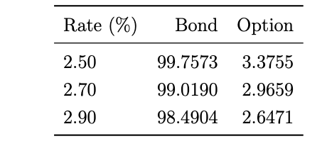
Here we use F as the price of the option
$$\frac{∂F}{∂r}≈\frac{ΔF}{Δr}=\frac{2.6471-3.3755}{0.004}≈-182,1$$
Q2
We want to be hedged against a change in interestrates being long one opion thus have a portfolio
$$P=F+α·B$$
And we want to have
$$\frac{∂P}{∂r}=0$$
Using the approximations
$$\frac{∂P}{∂r}≈-182,1+α·-316,725=0$$
$$α=-0,5749467$$
Thus we go short about 0.57 bonds to hedge our interestrate risk
Q3
$$P_{0}=2.9659-99.0190·0,5749467≈-53,9647473$$
$$P_{1}=2.6471-98.4904·0,5749467≈-53,9796305$$
$$ΔP=-53,9796305--53,9647473≈-0,0148832$$
Meaning we loose about 0.014 on the hedged position which is not to bad considering the high sensitivities to yieldchanges
Q4
$$D_{mod}=-\frac{∂P}{∂λ}·\frac{1}{P}$$
Saying
$$\frac{∂P}{∂λ}≈\frac{∂P}{∂r}≈\frac{ΔP}{Δr}$$
$$D_{mod}^{B}=\frac{316,725}{99.019}≈3,1986285$$
$$D_{mod}^{F}=\frac{182,1}{2.9659}≈61,3978893$$
Q5
Perpetuity pays 10 semiannually with a YTM of 5%
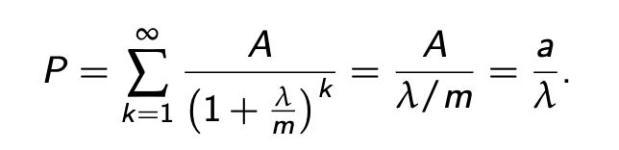
$$P=\frac{20}{0.05}=400$$
$$\frac{∂P}{∂λ}=-\frac{a}{λ^{2}}$$
$$D_{mod}=-\frac{1}{P}·\frac{∂P}{∂λ}=\frac{1}{λ}=\frac{1}{0.05}=20$$

Q7
$$ϕ_{0}=0.03$$
Rest I have no idea

Exercise 2
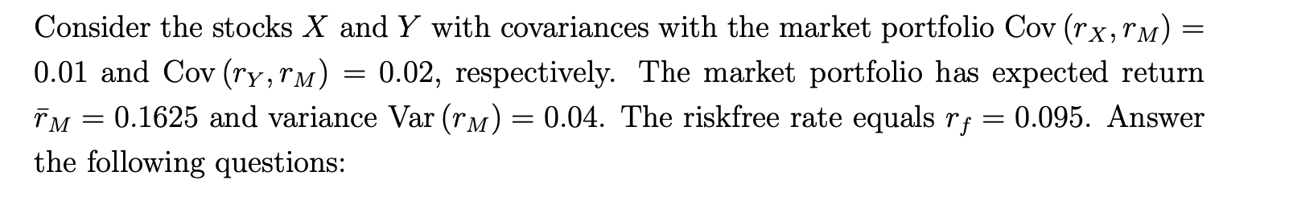
Q1
$$β_{X}=\frac{σ_{X,M}}{σ_{m}^{2}}=\frac{0.01}{0.04}=0,25$$
$$β_{Y}=\frac{0.02}{0.04}=0,5$$
According to capm
$${\overline{r}}_{p}=r_{f}+β_{p}·\left({\overline{r}}_{m}-r_{f}\right)$$
$${\overline{r}}_{X}=0.095+0.25\left(0.1625-0.095\right)=0,111875$$
$${\overline{r}}_{Y}=0.095+0.5\left(0.1625-0.095\right)=0,12875$$
Q2
$$β_{P}=0.25·β_{X}+0.75·β_{Y}=0.25·0,25+0.75·0,5=0,4375$$
The expected return stated
$${\overline{r}}_{p}=\frac{100}{89.5}-1≈0,1173184$$
Expected return according to capm
$${\overline{r}}_{p}=0.095+0,4375\left(0.1625-0.095\right)≈0,1245313$$
According to capm the return is to low in other words the asset is to expesive and you should not invest

Q3
$$β_{P}=0.75·β_{X}+0.25·β_{Y}=0.75·0.25+0.25·0.5=0,3125$$
According to CAPM
$$\overline{r_{p}}=0.095+0,3125\left(0.1625-0.095\right)≈0,1160937$$
Which is just below the $0,1173184$ from his personal expectations calculated earlier
This means that yes he should invest since his expected return is higher than his theoretical one form capm

These 2 assignments are done as I think intended without thinking about a personal utility function of the investor and arguing purely from capm

Q4
$${\overline{r}}_{p}=r_{f}+λ_{1}·b_{1}+λ_{2}·b_{2}=0.095+0.06·0.25+0.08·0.125=0,12$$

Q5 in atp the $λ^{'}s$are the socalled cost of risk or how much extra return you can expect for holding one unit of factor exposure, it is how much you gain for holding risk

Q6 I believe we are to find the market portfolio that makes the ATP model and CAPM are alligned

We find the weights such that
$${\overline{r}}_{X}·α+{\overline{r}}_{Y}·\left(1-α\right)=0.12$$
$$0,111875·α+0,12875·\left(1-α\right)=0.12$$
$⇕$ Ligningen løses for α vha. WordMat.
$$α=0,5185185$$
$$w=\left(\begin{aligned}0.5185185 \\ 1-0,5185185\end{aligned}\right)=\left(\begin{matrix}0,5185185 \\ 0,4814815\end{matrix}\right)$$

Exercise 3
$$D=\left(\begin{matrix}10 & 15 & 22 \\ 8 & 17 & 9\end{matrix}\right)$$
$$P=\left(\begin{aligned}10.5 \\ 8.9\end{aligned}\right)$$
Q1
$$ψ=\left(\begin{aligned}0.3 \\ 0.25 \\ 0.25\end{aligned}\right)$$
$$Dψ=\left(\begin{matrix}10 & 15 & 22 \\ 8 & 17 & 9\end{matrix}\right)\left(\begin{aligned}0.3 \\ 0.25 \\ 0.25\end{aligned}\right)=\left(\begin{matrix}12,25 \\ 8,9\end{matrix}\right)≠P$$
It is not a statepricevector
If it was the market would be arbitragefree
When the market is arbitragefree it is complete if and only if D is invertible but rank(D)<=2<3 thus not invertible
Q2
$$r_{f}=\frac{1}{0.8}-1=0,25$$

Q3
Assuming that the stateprice vector works even though it does not
We will price it using that statepricevector even though its not unique
The option pays out
$$D_{opt}=\left(\begin{matrix}0 & 3 & 10\end{matrix}\right)$$
We do statepricing
$$P_{opt}=\left(\begin{matrix}0 & 3 & 10\end{matrix}\right)\left(\begin{aligned}0.3 \\ 0.25 \\ 0.25\end{aligned}\right)=3,25$$
Q4
$$D^{'}=\left(\begin{matrix}10 & 15 & 22 \\ 8 & 17 & 9 \\ 5 & 15 & 20\end{matrix}\right)$$
$$\left(\begin{matrix}5 & 15 & 20\end{matrix}\right)\left(\begin{aligned}0.3 \\ 0.25 \\ 0.25\end{aligned}\right)=10,25$$
Q5 given the statepricevector that is not a statepricevector no it is not cnsistent with no arbitrage its price is to low meaning we make free money

Exrcise 4
Q1
We note that in the tree we have constant $u=1.5, d=0.65 , r=0.05$
Thus we also have constant risk neutral probabilities
$$q=\frac{1+r-d}{u-d}=\frac{1.05-0.65}{1.5-0.65}≈0,4705882$$

Under Q we have
$$P\left(\text{"ud"}\right)=2·q·\left(1-q\right)=2·0,4705882·\left(1-0,4705882\right)≈0,4982699$$

Q2
Call:
Since no dividends and positive risk free rate
$$C_{A}=C_{E}$$
$$C_{uu}=225-85=140$$
$$C_{ud}=97.5-85=12,5$$
$$C_{dd}=0$$
$$C_{0}=\frac{1}{1.05^{2}}·\left({0,4705882}^{2}·140+0,4982699·12,5\right)≈33,7703667$$
Put:
We note that at time 2 we only exercise in the “dd” state
And if we go up the put is worthless since we never exercise
$$P_{u}=0$$
$$P_{ud}=0$$
$$P_{dd}=85-42.25=42,75$$
We calculate the value of exercising in the “d” state
$$P_{d}^{e}=85-65=20$$
We calculate the value of not exercising in the down state
$$P_{d}^{ne}=\frac{1}{1.05}·\left(1-0,4705882\right)·42,75≈21,5546233>20$$
Thus we do not exercise in the “d” state
And since there is no intrinsic value in state 0 in this case we can simply calculate
$$P_{0}^{A}=\frac{1}{1.05}·\left(1-0,4705882\right)·21,5546233≈10,867878$$
Q3
The model is free of arbitrage $⇔u>1+r>d$ in every period
We need to wory abount the “0” state and the “d” state
In the “0 state we must simply have
$$d<1+r=1.05$$
In the second state we must calculate new “up”/”down” values
$$u^{'}=\frac{97,5}{100·d}=\frac{0,975}{d}$$
$$d^{'}=\frac{42.25}{100·d}=\frac{0,4225}{d}$$
Thus for the 2. Period to be free of arbitrage we must have
$$u^{'}>1.05>d^{'}$$
D being positive
$$\frac{0,975}{d}>1.05>\frac{0,4225}{d}$$
$$⇔1.05d∈\left( 0.4225, 0.975\right)$$
$$\frac{0.4225}{1.05}≈0,402381≈0.4024$$
$$\frac{0.975}{1.05}≈0,9285714≈0.9286$$
Rounding a little
$$d∈\left(0.4024, 0.9286\right)$$
We note that
For this calculations we get different q’s in both states
$$q=\frac{1.05-d}{1.5-d}$$
$$q^{'}=\frac{1.05-d^{'}}{u^{'}-d^{'}}=\frac{1.05-\frac{0,4225}{d}}{\frac{0,975}{d}-\frac{0,4225}{d}}=\frac{1.05·d-0.4225}{0,975-0.4225}=1,8099548·\left(1,05·d-0,4225\right)$$
Meaning we can calculate the call price for an arbetrary d value we note that the C values at expiration remain the same
The probabilities in the up state are just the same as before and thus
$$C_{u}=69.047$$
For the down state we need to calculate
$$C_{d}=\frac{1}{1.05}·\left(q^{'}·C_{ud}\right)=\frac{1}{1.05}·12.5·1,8099548·\left(1,05·d-0,4225\right)=21,547081·\left(1,05·d-0,4225\right)$$
Now we need it in the “0” state
$$C_{0}=\frac{1}{1.05}·\left(q·C_{u}+\left(1-q\right)·C_{d}\right)=\frac{1}{1.05}·\left(\frac{1.05-d}{1.5-d}·69.047+21,547081·\left(1,05·d-0,4225\right)\right)=0,952381·\left(21,547081·\left(1,05·d-0,4225\right)+\frac{69,047·\left(1,05-d\right)}{1,5-d}\right)$$
We put in the bounds thinking I must be monotonic
$$0,952381·\left(21,547081·\left(1,05·0.4024-0,4225\right)+\frac{69,047·\left(1,05-0.4024\right)}{1,5-0.4024}\right)≈38,799209$$
$$0,952381·\left(21,547081·\left(1,05·0.9286-0,4225\right)+\frac{69,047·\left(1,05-0.9286\right)}{1,5-0.9286}\right)≈25,3096939$$

$$d∈\left(0.4024, 0.9286\right)$$
And
$$C∈(25,3096939, 38,799209$$

Q4
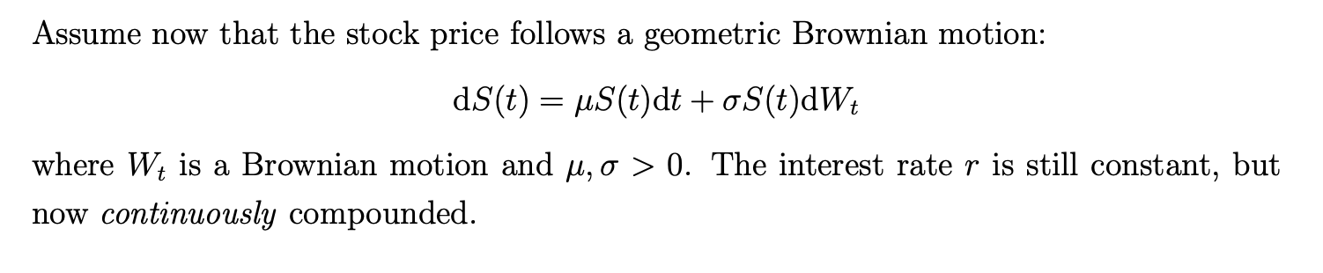
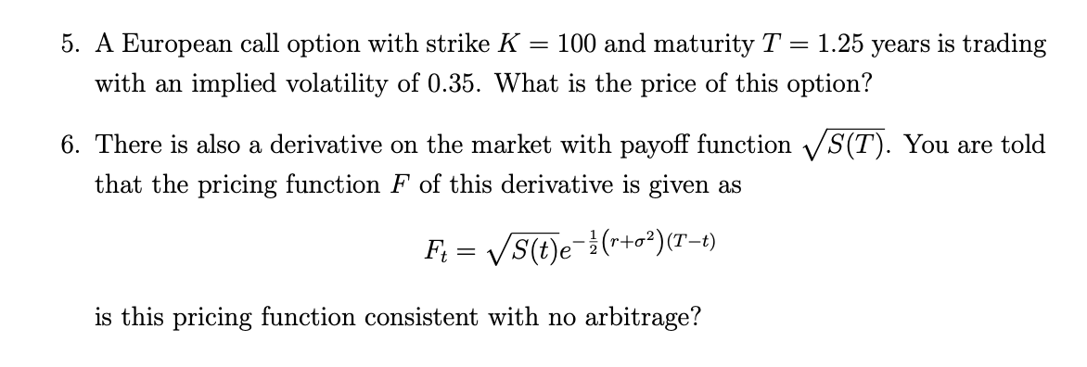
Q5 we note that we are In a BSM world and need to price a european call thus we simply use the BSM- call formula
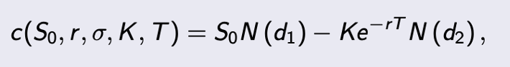

$$S=K=100$$
$$σ=0.35$$
$$T=1.25$$
$$r=0.05$$
We simply plug numbers into formula and get
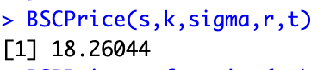

Q6 to check that it is consistent with no arbitrage we check boundary conditions and the BSM formula

At expiration the price must equal its payoff
$$F_{T}=\sqrt{S_{t}}·e^{-\frac{1}{2}·(r+σ^{2})(T-T)}=\sqrt{S_{t}}·1$$
Thus boundary conditions are satisfied
Thus we simply need
$$f\left(S,t\right)=\sqrt{S}·e^{-\frac{1}{2}(r+σ^{2})(T-t) }$$
$$r·f\left(t,S\right)=\frac{∂f}{∂t}\left(t,S\right)+r·S·\frac{∂f}{∂S}\left(t,S\right)+\frac{1}{2}σ^{2}S^{2}\frac{∂^{2}f}{∂S^{2}}\left(t,S\right)$$
$$\frac{∂f}{∂t}=\sqrt{S}·\frac{\left(r+σ^{2}\right)}{2}·e^{-\frac{1}{2}·\left(r+σ^{2}\right)·\left(T-t\right)}=\frac{\left(r+σ^{2}\right)}{2}·f$$
$$\frac{∂f}{∂S}=\frac{1}{2·\sqrt{S}}·e^{-\frac{1}{2}(r+σ^{2})(T-t) }=\frac{f}{2·S}$$
$$\frac{∂^{2}f}{∂S^{2}}=-\frac{1}{4·S^{\frac{3}{2}}}·e^{-\frac{1}{2}\left(r+σ^{2}\right)\left(T-t\right)}=-\frac{f}{4·S^{2}}$$
$$\frac{∂f}{∂t}+r·S·\frac{∂f}{∂S}+\frac{1}{2}σ^{2}·S^{2}·\frac{∂^{2}f}{∂S^{2}}=\frac{\left(r+σ^{2}\right)}{2}·f+r·S·\frac{f}{2·S}+\frac{1}{2}·S^{2}·σ^{2}·-\frac{f}{4·S^{2}}=\frac{3·f·σ^{2}}{8}+f·r=0,375·f·σ^{2}+f·r≠f·r$$

Thus no it does not satisfie the BSM equation and thus since
$$no arbitrage and BSM world⇒BSM eqation satisfied$$
$$BSM world, BSM equation not satisfied⇒arbitrage$$

